WildysWorld! ALWAN

Art Adventures

Private Travel Planner/Companion
Wildy will take care of everything and be there for you every step of the way!
A life-long world traveler and super curious artist with an eye for fun invites you to accompany her and enjoy the world with worry-free. She will book, cook, drive and provide . Your journey awaits!

Creativity and Travel Coach
Calling all souls who would like to open the connection to the fountain of creativity and life changing perspective. Through the eyes and heart of an artist who is completely fascinated by cultural immersion, you will practice unadulterated energy unfettered by judgement. Let’s live this live!

Art Instructor
Your course of study and practice will be specifically engineered to your custom objectives and interests (if ARTmaking is a goal of yours). You will have access to a private Art Instructor with 30 years in the field. Trained as a Fine Artist and Art Educator with an emphasis on Art History, Wildy Self has devoted her life to travel and the study of Art and Culture.

Adventure Guide
Where would you like to go? How many will be traveling with Wildy? How long do you want to EXPLORE? (2 weeks / 3 weeks 1 month) Would you enjoy seeing the whole country if possible ( total immersion – 1 month) Do you prefer the sand/sea/sun/forest/jungle/beach?

Liason
Wildy will take you on the trip of your life. Her unique style of exploration and adventure has a style of delightful spontaneity that will be planned into the foundation of the excursions, experiences and events so that we are able to do what YOU want to do and live you’re your dream.

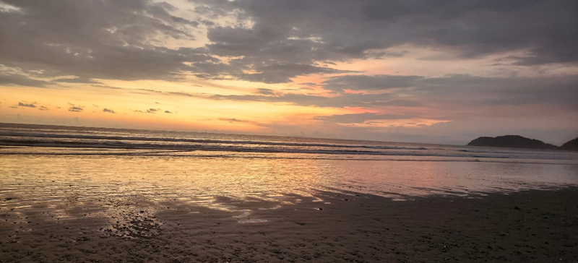

TRIPS MENU

All trips are uniquely designed to meet your goals and individual focus areas

Trips are designed for 1 – 3 people. This is a PRIVATE Adventure. You will travel with Wildy as your as your professional TRAVEL COMPANION and Guide/Liason

1 WEEK 2 weeks 3 weeks

1 month - see the whole country
We rent a car and Wildy will chauffeur you to all of the most beautiful places as your PRIVATE ADVENTURE COACH/GUIDE/COMPANION
When you travel with the UNtourist you know we will seek the road less traveled to see the most authentic treasures in every country.

Art Adventures
All things ART! Art Museums/Galleries/Events/ARTmaking/skills/practice
We will see all of the most breathtaking sites with our paints and pencils in hand, plein-air watercolor in the park, sketchbook at the beach, journaling and beautifully documenting the treasure we find as we wander through paradise

